**Auto Allocation Using “Outbound Activity”**

1. We created the following outbound activity, in order for orders to auto allocate.

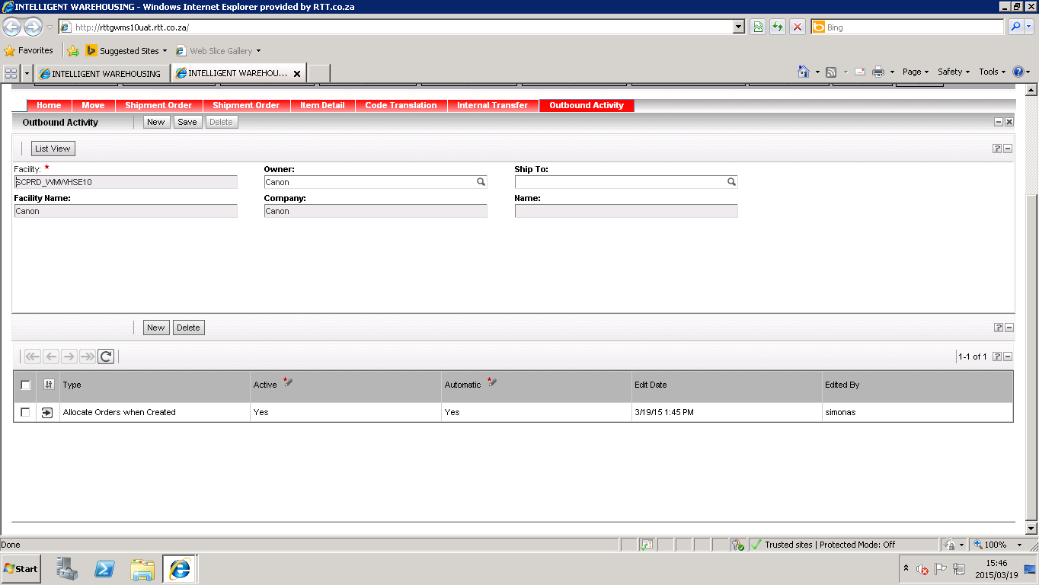

1. We then interfaced an order to the system and nothing happened.
2. We then created the order from the front end of the WMS, and the order automatically allocated.